Instructions for Payments for “Trip Payments” on
Educational Tours, Inc.’s Payment Portal Page

Trip #18-03071 – Chapel Hill High School Orchestra

- At www.tours-eti.com, click on MAKE A PAYMENT.
(A link is also at the bottom of the home page that says Payments.)

- Click on PAY NOW.

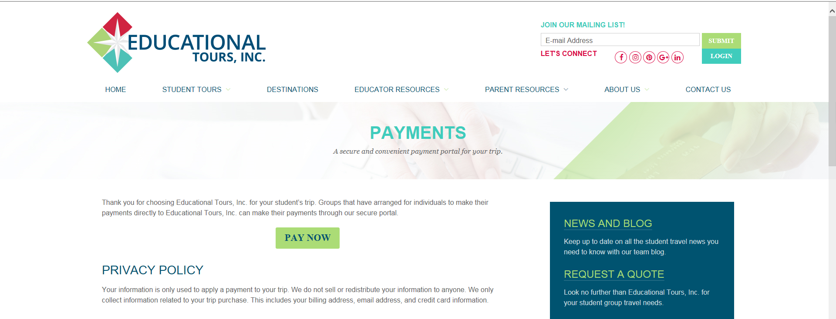

- Click on “Register” in the lower left hand corner.

- Register yourself with your billing address for your Visa or MasterCard, email and password. Save. *This is the billing address for the card & the email receipt. If this does not match your issuing bank address your payment will not process. Just click on Log In after registering the first time.

- Log in using your email & your password.

- Add your Trip Number (format example: 18-03071) to add your trip. You will then see the number of the trip and the name of the trip.

- Add as many participants as you are paying for. At the end of each participants name you will see a “pay” button. Click this. The next screen will be where you fill in the amount of the trip payment. Please note that if you enter your name only with no payment you will be put on the “Waiting List”. Making a scheduled payment amount will enroll your name on the Official Trip Roster. You will need to refresh the screen after making the first payment to change from “Waiting List” to “Traveling”.
(Refresh by either changing to a different screen and then go back to this screen to update it or use the F5 button at the top of your keyboard to refresh.)

- Fill in the amount of your travel protection payment in the “Travel Protection Amount” field. If travel protection has already been purchased or provided on your behalf, leave 0.00 in the field. Fill in the amount of your trip payment in the “Trip Payment” field.

- Enter your Visa, MasterCard or American Express number, expiration date and the 3 or 4 digit security number (last number on the backside of your card). Click “Submit”. You will see a green “Thank you” and receive an email confirmation for that purchase. If you see a “Sorry, your payment cannot be processed” notice, it is either due to a typing error or the issuing card company rejecting it. It is not ETI or the website determining the rejection. Please retype and submit again to see if you had typing errors or check with your issuing card company to resolve the problem. A confirmation email will state this too for reference. (Refer back to number 01 above.)

- Log out.

- If you would like to change the billing address for the card you are using or your password, do this by clicking, “Manage Account” in the uppermost right hand corner of the screen when logged in. If you let someone else use your portal to make a payment for your participant(s) then they can change the name and address on the payment screen before submitting the payment.
- Log out until next time when you will log in with your email & password. If you have forgotten your password the link to recover that is in the lower left hand corner of the “Log in” Screen.

